 

**School Of Mechanical & Manufacturing Engineering(SMME)**

**> Assignment # 0 1**

**> Course Instructor: Dr Jawad Khan**

**> Lab Instructor: Muhammad Affan**

**> Student Name: M.Touseef Akhtar**

**> CMS ID: 460700**

**DATE: 28/09/2023**

**1__Distance between two points :**

**D = (x2-x1)2 + (y2-y)**

**CODE:**

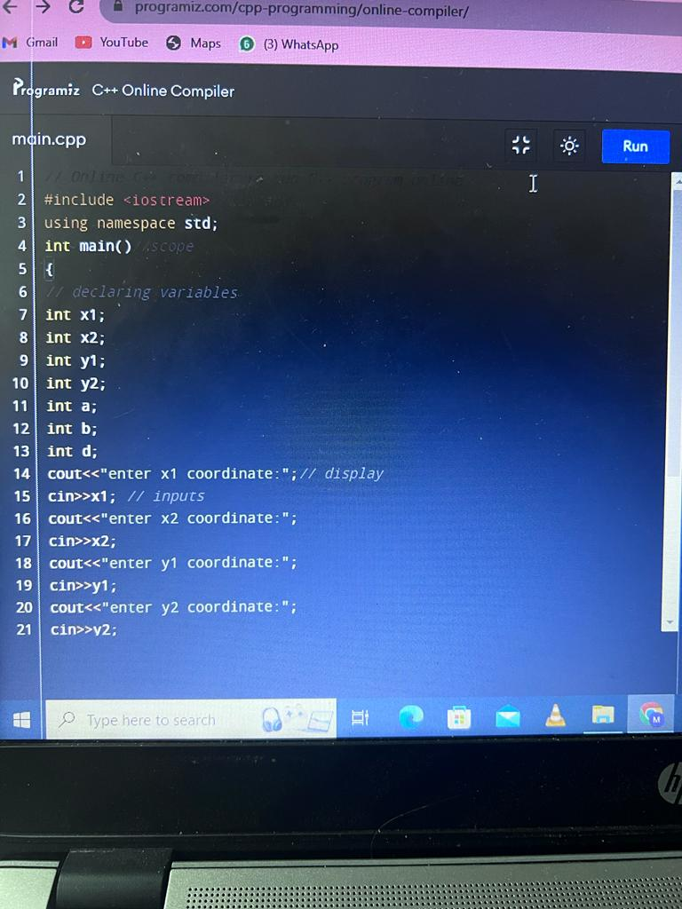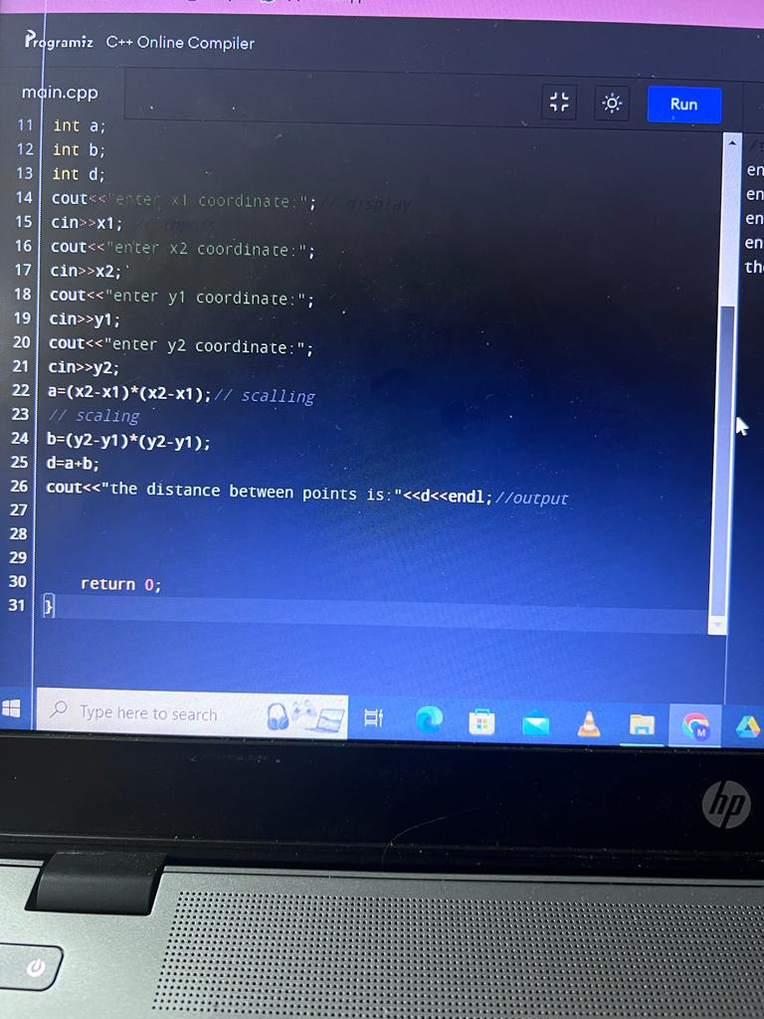

**RESULTS:**

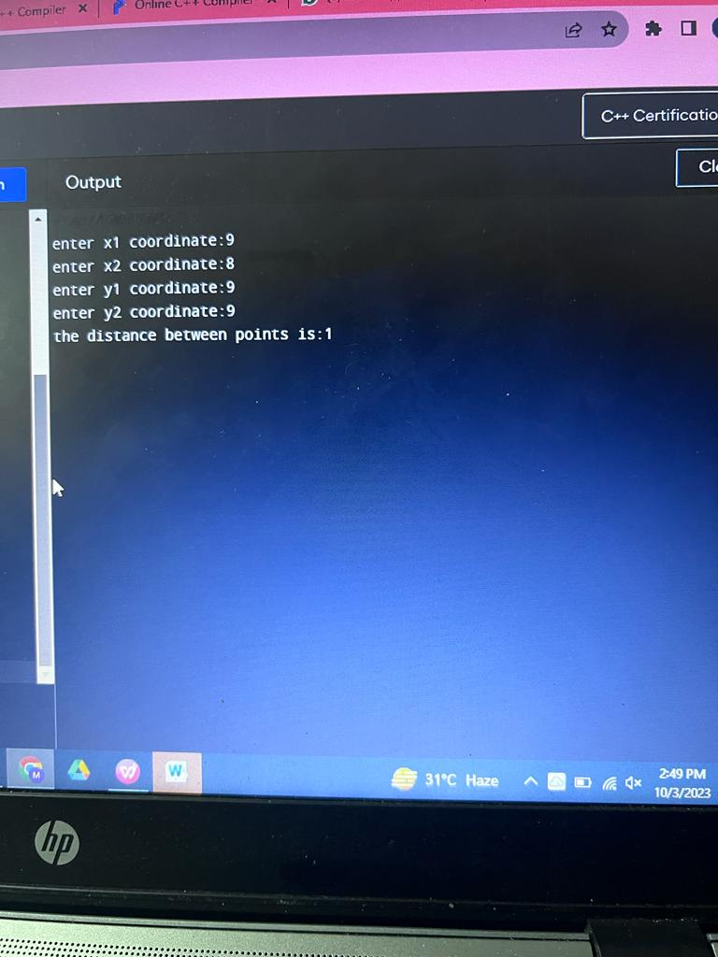

**2__Converting Centimeters into meters and kilometers:**

**CODE:**

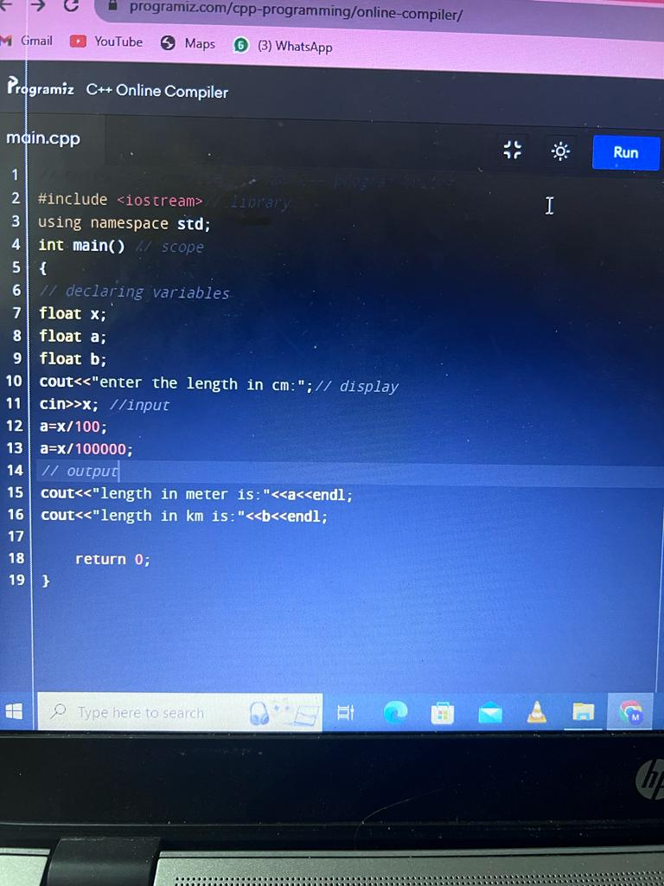

**Result:**

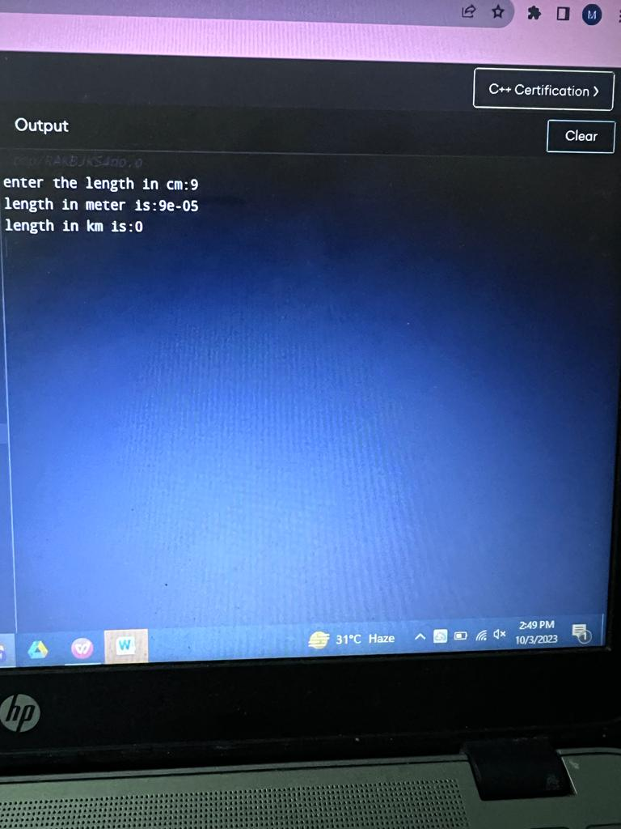

**3__Result of polynomial :**

**a2 +2ab +b2:**

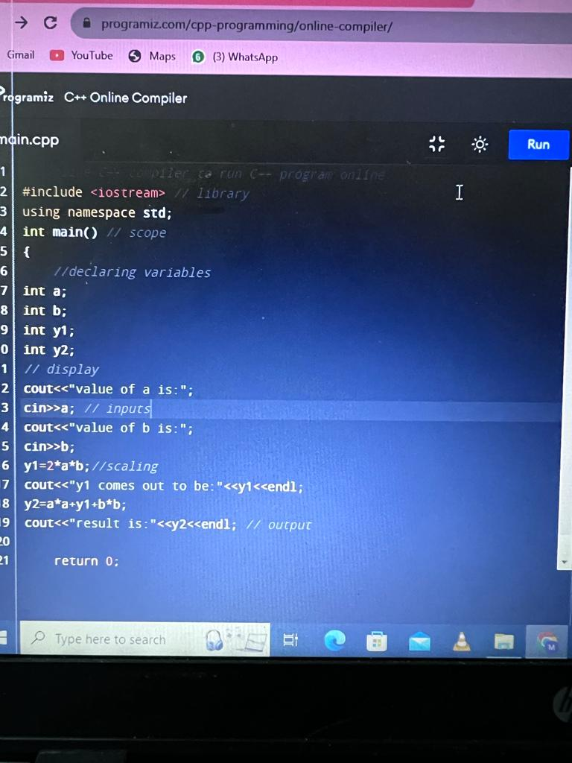

**Result:**

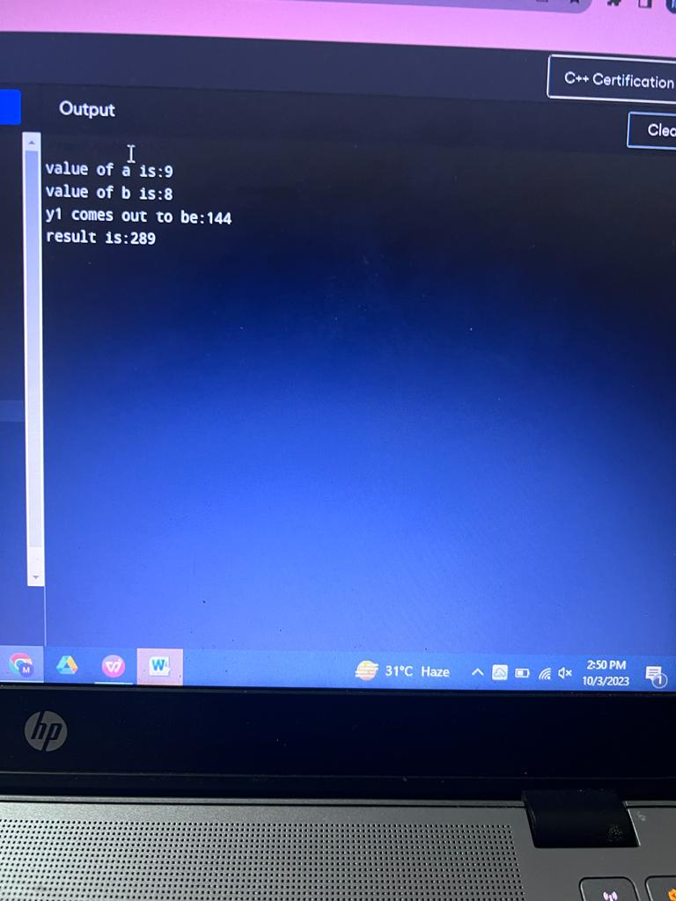

**4__Converting Fahrenheit into Celsius:**

**CODE:**

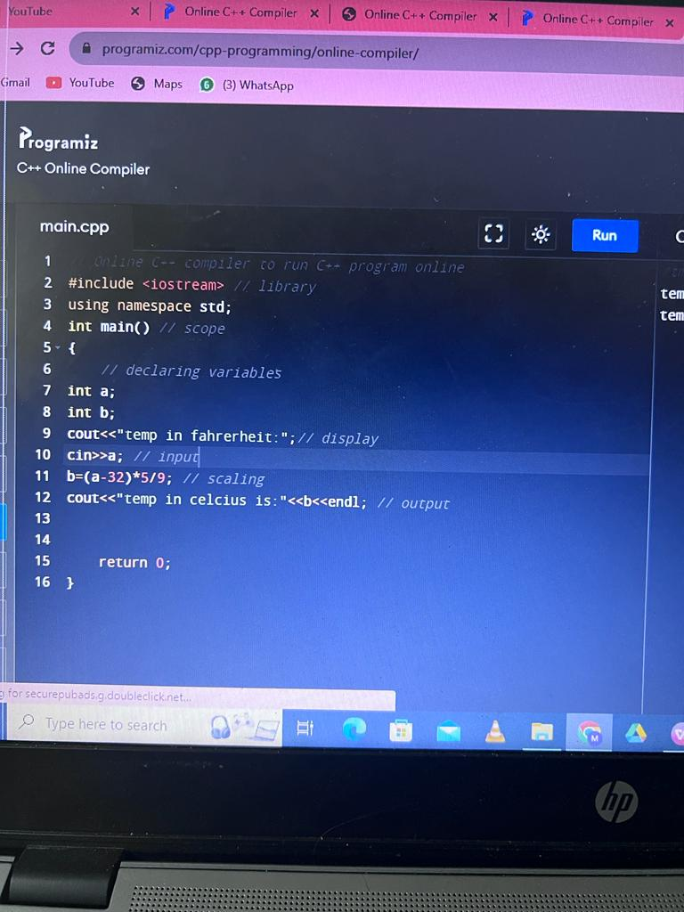

**RESULTS:**

